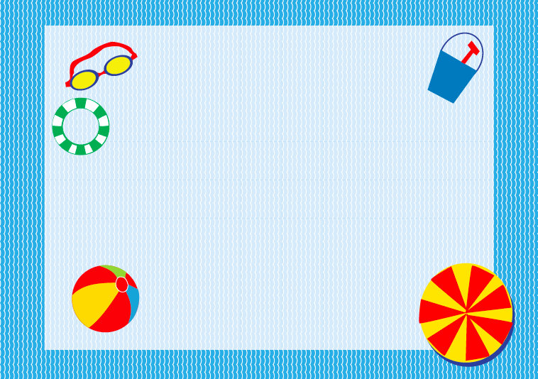



SUNGLASSES

M

SUNSCREEN

M